WEEK-2
Project 1: Spring Core IoC (LibraryManagement)
Exercise 1: Configuring a Basic Spring Application Scenario: Your company is developing a web application for managing a library. You need to use the Spring Framework to handle the backend operations.
Steps:
- Set Up a Spring Project: Create a Maven project named LibraryManagement. Add Spring Core dependencies in the pom.xml file.
- Configure the Application Context: Create an XML configuration file named applicationContext.xml in the src/main/resources directory. Define beans for BookService and BookRepository in the XML file.
- Define Service and Repository Classes: Create a package com.library.service and add a class BookService. Create a package com.library.repository and add a class BookRepository.
- Run the Application: Create a main class to load the Spring context and test the configuration.
Exercise 2: Implementing Dependency Injection Scenario: In the library management application, you need to manage the dependencies between the BookService and BookRepository classes using Spring's IoC and DI.
Steps:
- Modify the XML Configuration: Update applicationContext.xml to wire BookRepository into BookService.
- Update the BookService Class: Ensure that BookService class has a setter method for BookRepository.
- Test the Configuration: Run the LibraryManagementApplication main class to verify the dependency injection.
Exercise 4: Creating and Configuring a Maven Project Scenario: You need to set up a new Maven project for the library management application and add Spring dependencies.
Steps:
- Create a New Maven Project: Create a new Maven project named LibraryManagement.
- Add Spring Dependencies in pom.xml: Include dependencies for Spring Context, Spring AOP, and Spring WebMVC.
- Configure Maven Plugins: Configure the Maven Compiler Plugin for Java version 1.8 in the pom.xml file.

I created a raw Maven project from scratch to demonstrate Spring's Inversion of Control (IoC). You configured an XML context file to manually wire a Repository bean into a Service bean using setter injection.
pom.xml
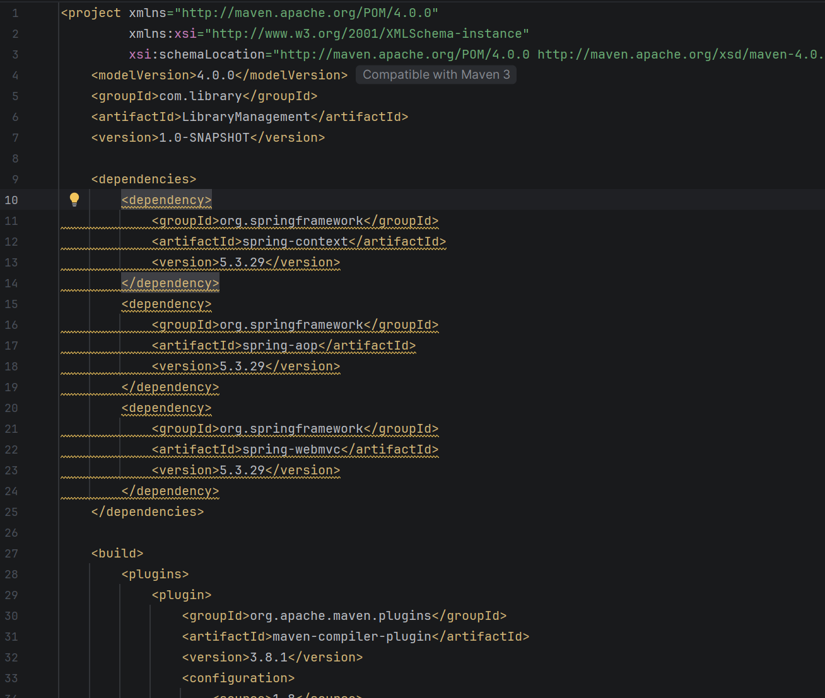

src/main/resources/applicationContext.xml
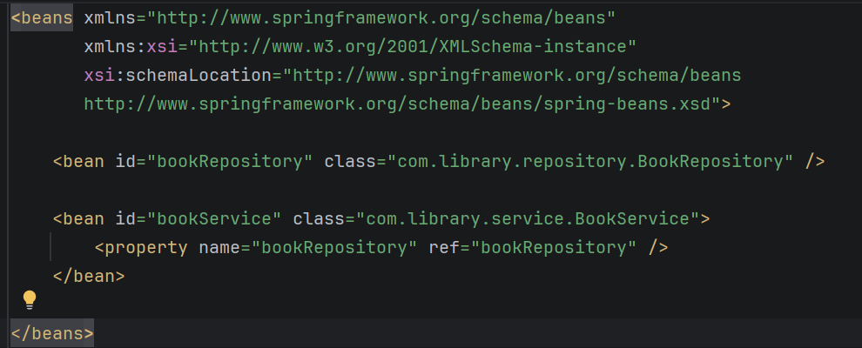
src/main/java/com/library/repository/BookRepository.java
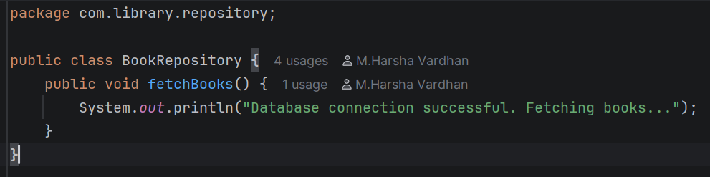
src/main/java/com/library/service/BookService.java
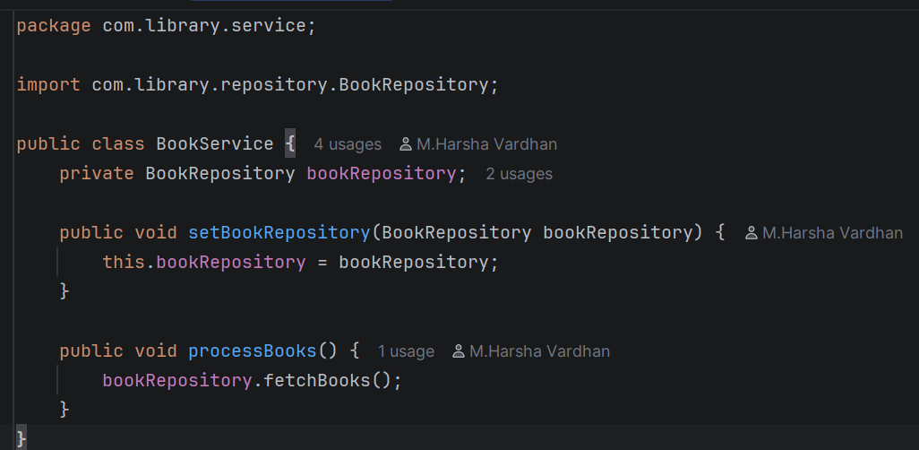

src/main/java/com/library/LibraryManagementApplication.java
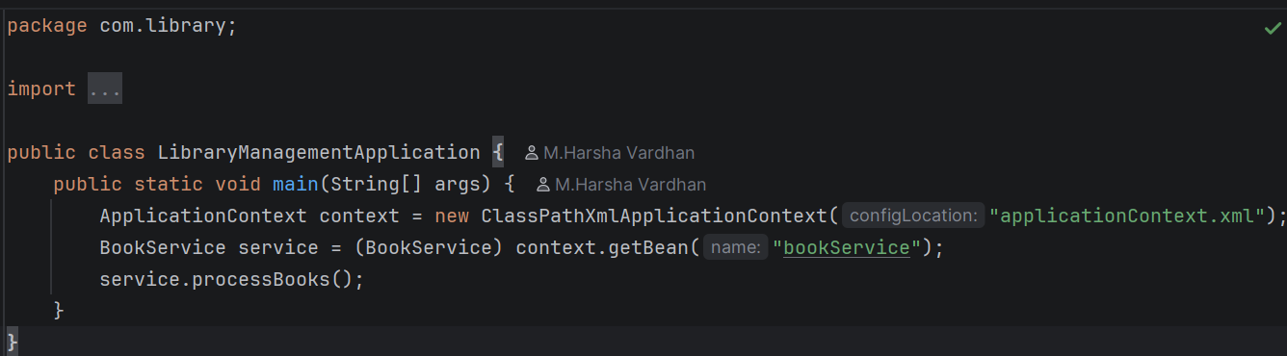

Execution Result :
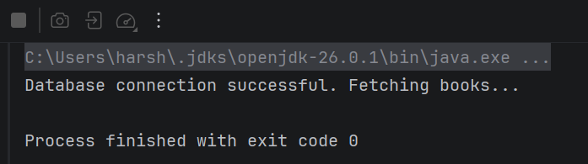

Exercise Requirements
Hands on 1: Spring Data JPA - Quick Example Scenario & Setup: Create a project using Spring Initializr with the Group com.cognizant and Artifact orm-learn. Include dependencies for Spring Boot DevTools, Spring Data JPA, and MySQL Driver. Create a new schema ormlearn in your MySQL database and set up a country table. Configure application.properties with the necessary database connection details and Hibernate log configurations.
Implementation Steps:
- Persistence Class: Create a Country class with @Entity, @Table, @Id, and @Column annotations mapping to the database table.
- Repository Class: Create a CountryRepository interface that extends JpaRepository<Country, String>.
- Service Class: Create a CountryService with a @Transactional method getAllCountries() that invokes the repository's findAll() method.
- Testing: In OrmLearnApplication.java, fetch the service bean from the application context and print the list of countries to the console.
Hands on 5: Implement services for managing Country Configuration & Data: Set spring.jpa.hibernate.ddl-auto=validate in your properties file. Populate the country table in your database with the complete list of world countries provided in the SQL script.
Hands on 6: Find a country based on country code Implementation Steps:
- Exception Class: Create a CountryNotFoundException class.
- Service Method: Add a @Transactional method findCountryByCode(String countryCode) in CountryService. Use the repository's findById() method. If the country is not present, throw the exception.
- Testing: Add a new method in OrmLearnApplication to invoke this service method with a valid country code (e.g., "IN") and verify the output.
Project Files
src/main/resources/application.properties
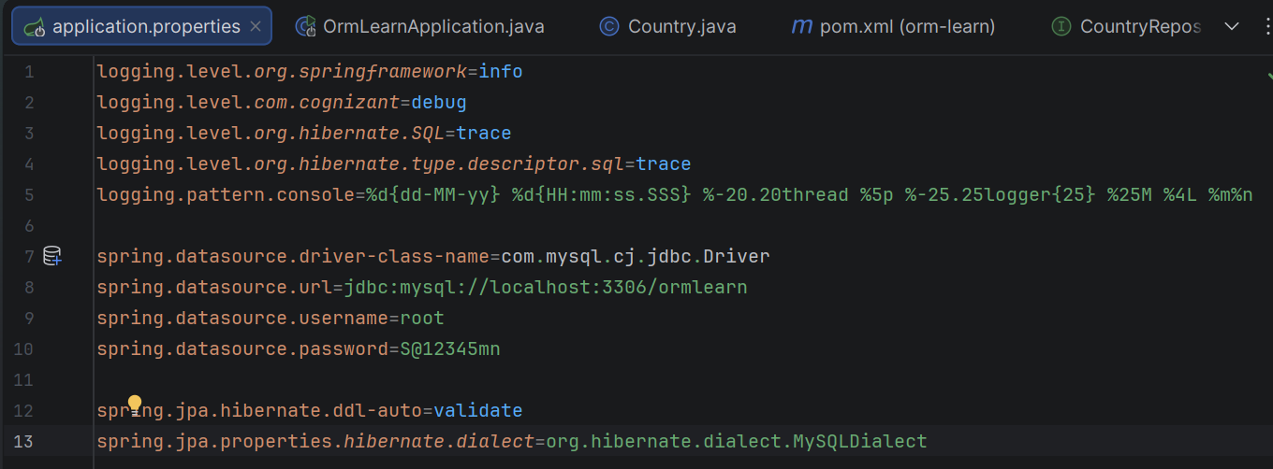
src/main/java/com/cognizant/ormlearn/model/Country.java
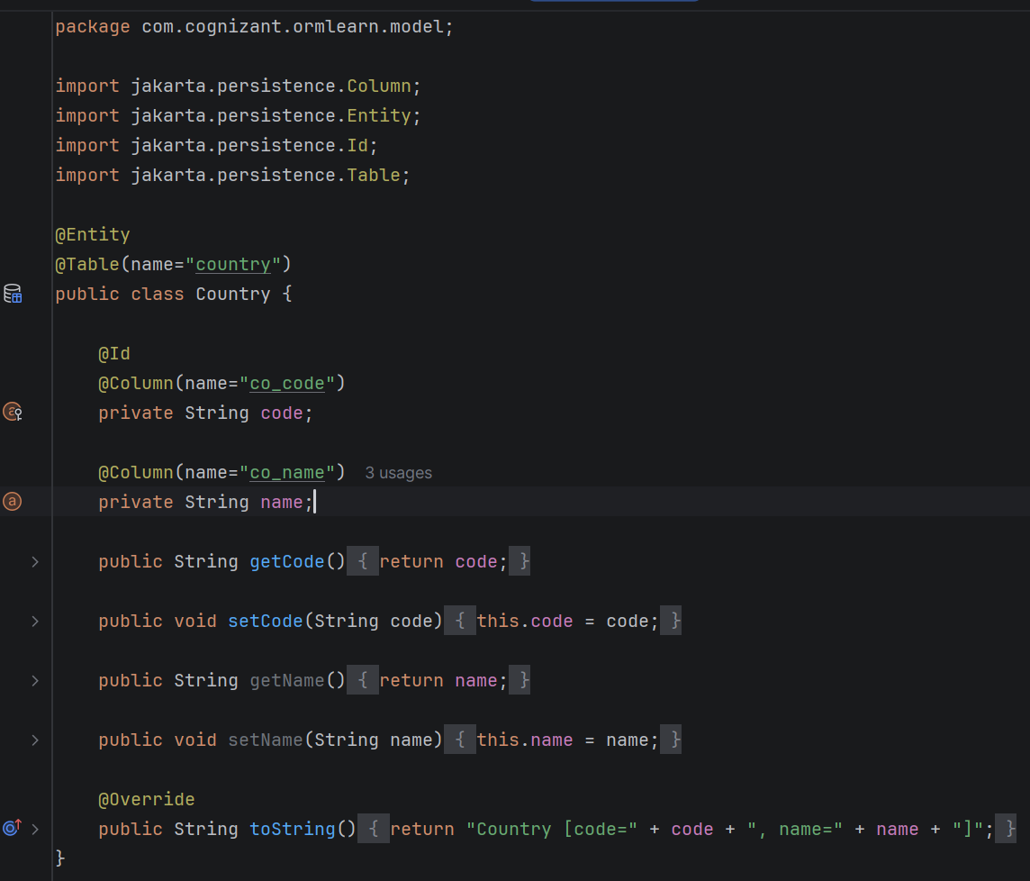

src/main/java/com/cognizant/ormlearn/repository/CountryRepository.java
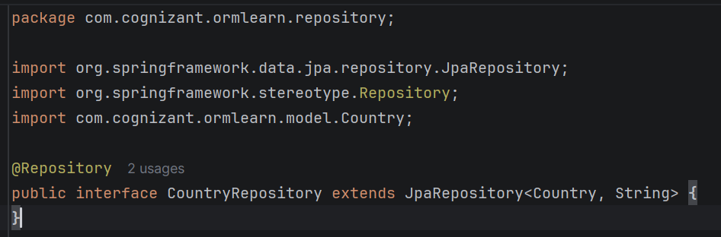
src/main/java/com/cognizant/ormlearn/service/CountryService.java
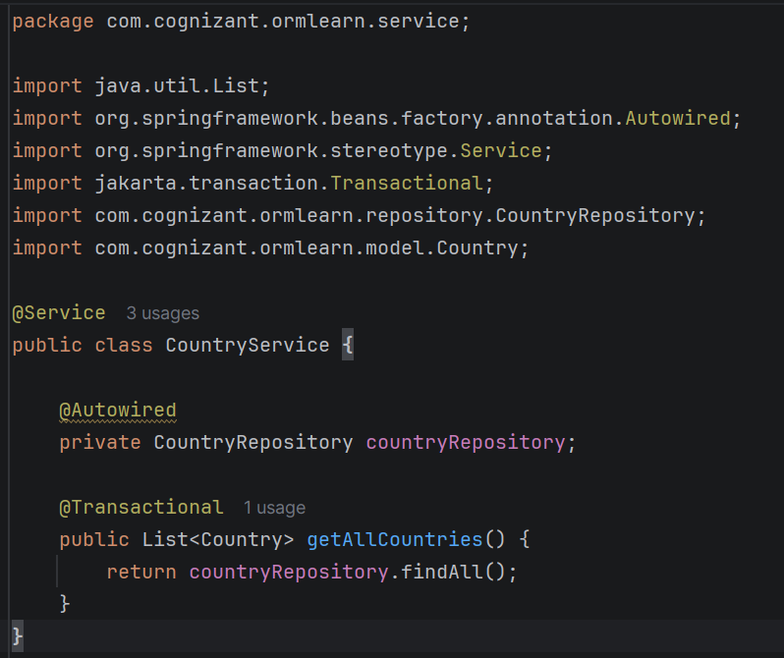
src/main/java/com/cognizant/ormlearn/OrmLearnApplication.java
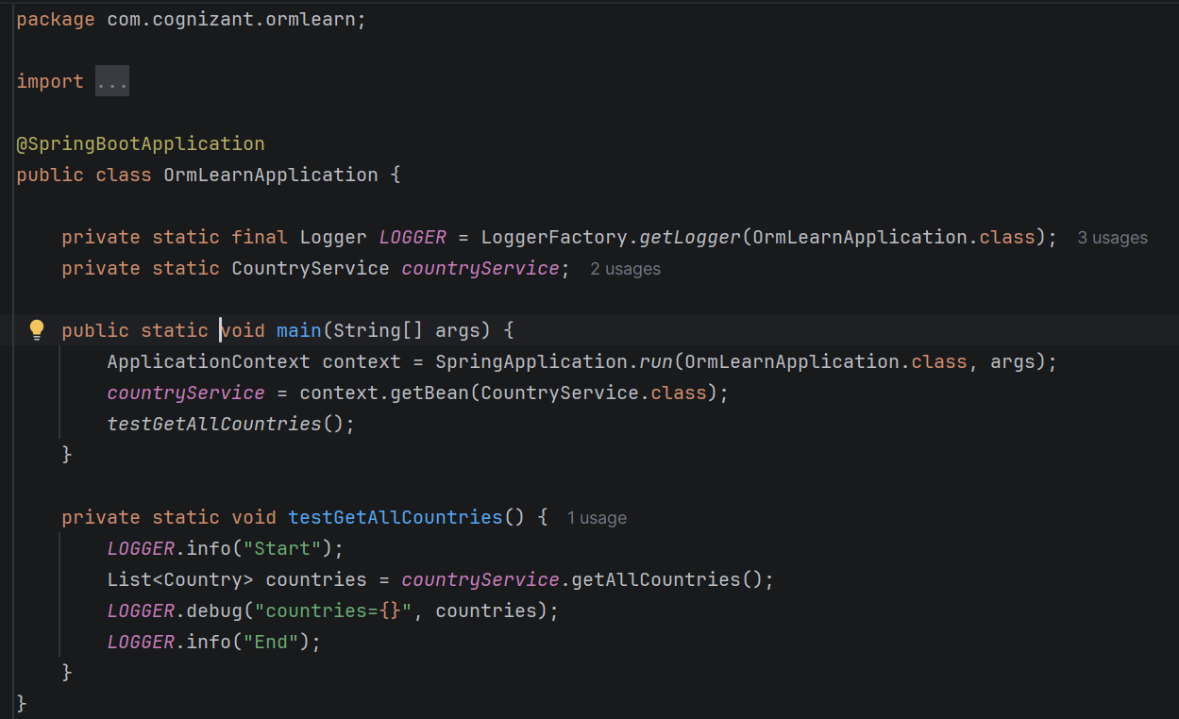

Execution Result:
